The Evidence is In: The CAT Speaks
A report to the members of Zion Redeemer Parish
February 22, 2023
Providing your church options that best fit your needs today for the sake of your mission tomorrow
Pastor Kurt Jacobson, Interpretive Consultant Mustard Seed Consulting, LLC
GoMustardSeed@gmail.com

Participants in the C.A.T.
35 Zion
53 Redeemer
18 Didn’t not indicate
106 Total respondents

Key Indicators about Z-R Parish:
- One-third of members are satisfied with things in the church; 60% are unsure.
- 26% of respondents to the CAT indicate they worship less than 5 times per year or never.
- 39% agree that participation in activities beyond worship is very meaningful to them.
- Members can envision a more vital church than they are currently experiencing. Energy & morale is low.
- The parish has a conservative theological stance, with low diversity among members.
- 2/3 of respondents say spiritual is really the basis of their whole approach to life.

Key Transition Insights
- Members are comfortable with the timing of the pastoral transition and feel it is time for this change.
- 1/2 of members are unsure if the church should continue in the same direction it has taken in the recent past. ¼ believe it should. Conversation congregation-wide should ensue on future direction.
- A leadership style of pastor that would best fit Z-R Parish would include the characteristics of delegating authority, assigning responsibility and recognizing the contributions of others; Making changes very slowly by working patiently to insure ownership of the final result.

Members see these abilities as critical for the next pastor: (in rank order)
- Preaching that inspires and connects people to God’s word.
- Pastoral care – capacity to engage people empathetically & care for persons in times of need.
- Strategic leadership – casting a vision and leading the church toward realization of the vision.

Priorities
As members look to the future, their top two priorities where they want additional energy placed are:
- Make necessary changes to attract families with children and youth to our church.
- Develop and implement a comprehensive strategy to reach and incorporate new people into the church.

In comparison to other churches, two priorities that are unusually strong for your parish are:
- Deepen the sense of connection to God and one another through stronger worship services.
- Strengthen the pastoral response of the church in serving people in times of need.

Financial Information
The CAT asked one person from each household to confidentially and anonymously reveal annual household income and annual giving:
- Total church income: $127,895
- Average annual household income: $61,373
- Average annual contribution: $853
- Average percent of income contributed: 1.39% (13th percentile in database of 2,600 churches. The average for ELCA congregations is 2.3%)

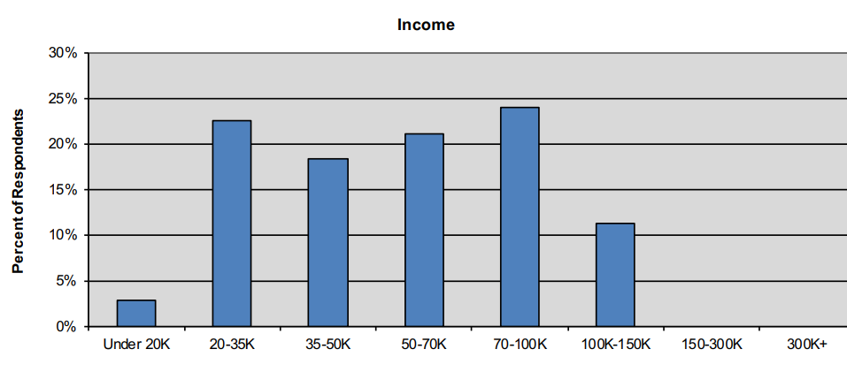

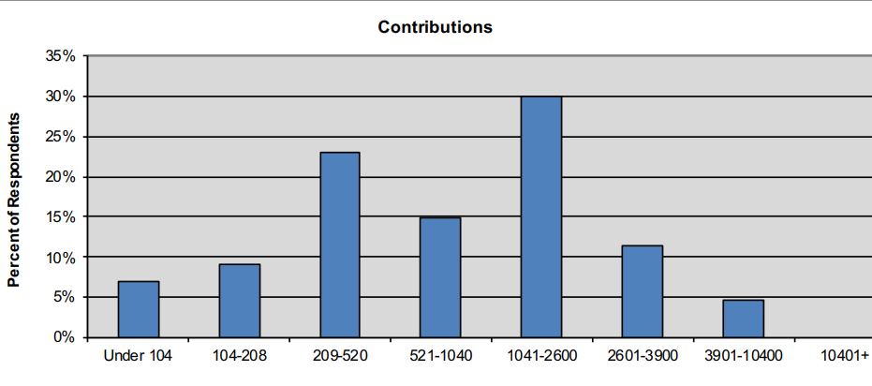

Quick Facts about Who Participated in the CAT (Church Assessment Tool)
- 106 responded to the CAT which is 180% of average worship attendance. The goal was 80%.
- Households: 28% are 3+ persons; 47% are two-person; 25% are one-person
- Tenure: 73% have been members 20+years; 16% -10 yrs. and less.
- Worship trend: 28% indicate worshiping less than 3 years ago; 17% indicate more than 3 years ago.
- Education attainment: 26% high school diploma; 29% some college; 18% college graduate; 2% some post graduate work; 22% graduate degree.
About the Consultant
Pastor Kurt Jacobson is a Holy Cow! Consulting trained interpretive consultant. He is an ordained pastor of the Evangelical Lutheran Church in America. For 28 years he served Trinity Lutheran Church, a transformational congregation of the ELCA in Eau Claire, WI. He retired as Lead Pastor in 2016. He has served as an interim pastor and consultant for congregations across the NW Synod of WI and beyond.
Jacobson holds a BA in Business/Hospital Administration and Organizational Communications from Concordia College, Moorhead, MN and a Master of Divinity degree from Luther Seminary, St. Paul, MN. Additionally, he holds a certificate in Intentional Interim Ministry from the National Association of Lutheran Interim Pastors.
He is the author of “Welcoming Grace: Words of Love for All” and “Living Hope: Messages of Faith. In addition, the book “The State of the ELCA” by J. Russell Crabtree, founder of Holy Cow! Consulting, Inc. includes a chapter detailing the work Kurt did in making Trinity Lutheran Church, Eau Claire, WI a transformational congregation.
He lives near Cumberland, WI.
Email: gomustardseed@gmail.com Facebook: Mustard Seed Consulting www.mustardseedonline.com

