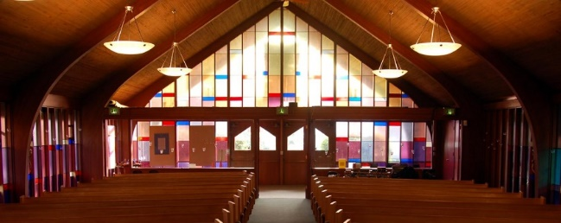
Why aren’t people coming back?
A letter to pastors and churchgoers who wonder what happened to the pre-pandemic church they knew.
December 5, 2022

Dear Friend:
I am going to assume you’re a positive person who enjoys people, radiates goodness, and thrives on hope. I’m also going to assume you’re familiar with discouragement. So, tell me if I have this much right: sometime in the last year you looked out over the sanctuary and congregation you love, and you wondered, What happened to the people? Why did so many kiss congregational life good-bye?

If you’ve contacted any of these absent parishioners, you may well have learned that they’re doing just fine. Their weekends are active and full. They either endured COVID or escaped it altogether. They sound healthy and well. The topic of church may have surfaced briefly when you spoke, but it didn’t seem to be very high on their priority list. So what should you do?

Well, keep the doors of your church and heart wide open. Don’t write off anyone’s place in your community unless they insist on it. Restarting a lapsed habit of any kind, remember, can be more difficult than creating and cultivating a brand-new one.

I wouldn’t overanalyze why all sorts of people aren’t showing up. Your church may be as good as any. Let’s not forget the growing secularization of culture and rising religious indifference staring us all in the face. Much of the public perceives faith as having limited social value. “We now live in a time,” says Andrew Root, “where the very idea that God is real and present in our lives is no longer accepted. Indeed, it’s widely contested.” Skepticism about the benefits of religious community has caused many people to quit looking to the church for personal meaning or identity.

Because you are a person of faith who leans into Christian community, however, there are some things to keep in mind when you’re discouraged.

First, remember that God has given the church a bigger and better hope than what the world lives by. How you communicate this beautiful idea that we follow a light brighter than the flicker of our own little bulb is up to you.

Second, don’t forget to love your Christian community as you find it, not merely as you wish it were. That’s Dietrich Bonhoeffer’s idea, not mine. He also reminds us that there’s no way to know Christ apart from Christian community. Christus als Gemeinde existierend—Christ exists as community. Anybody can talk up their love for Jesus. But the church is the one place where we actually meet the living and present Christ.

Third, remind yourself that your church needs to welcome and accept people for who they are—if it is to be any kind of magnet in your community—and then love them into who they get to become in Christ.

Fourth, keep looking for ways to grow and share the bubbling energy that ought to be evident in your church when people come together around a shared purpose. Émile Durkheim coined the term collective effervescence to describe what happens when communal gatherings foster a deep religious experience.

Finally, delight in every sign of your congregation’s faithfulness. Fixating on who’s not in the pews is a worthless and suffocating exercise. There is no convincing anybody of their need for Christian community. They have to want it. And their best chance for discovering that desire may come from observing the joy that’s in you.

Your companion on the journey,

Peter

Peter W. Marty
Marty is editor/publisher of the Century and senior pastor of St. Paul Lutheran Church in Davenport, Iowa.

